Hadoop Cluster Overview

* Cluster overview at [http://localhost:9870](http://localhost:9870/)

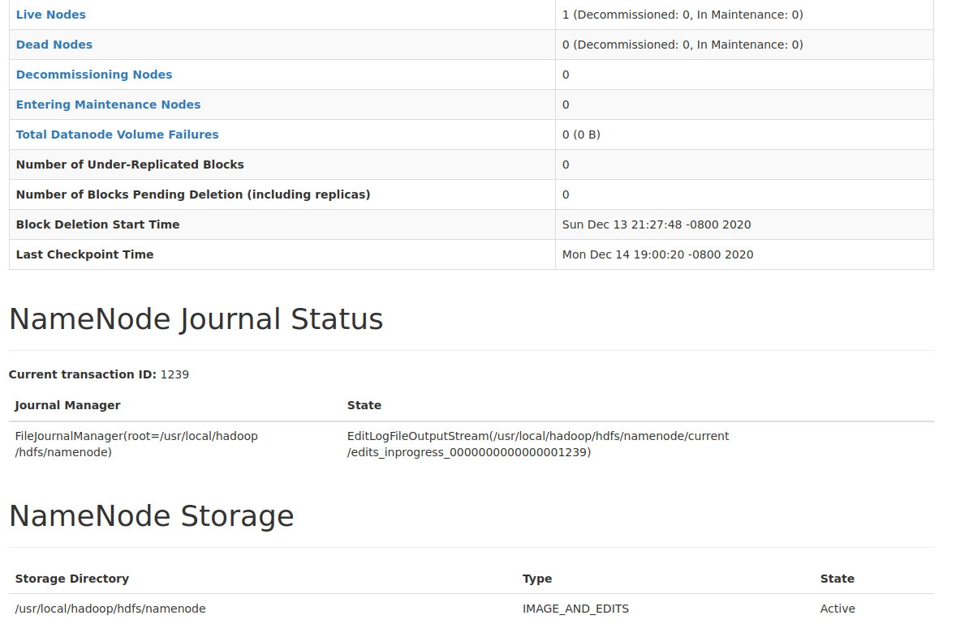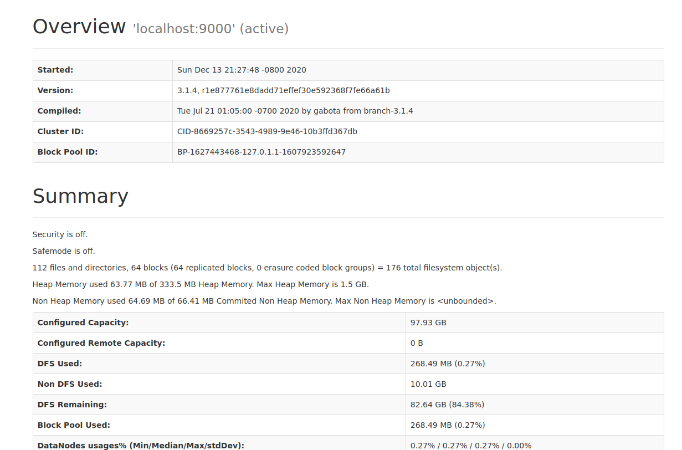

* Cluster running at <http://localhost:8088>

